**3 | RESULTS**

***3.1. Regional scale***

We resampled our abundance data across all lakes for each sampling method to look at the accumulation curves through an increasing gradient of samplings (Figure 3).

The number of infected individuals (A) and total number of individuals (B) increased linearly through the sampling gradient. The transect method sampled the most individuals than the other methods by far while the minnow trap method caught the least individuals. The accumulation rate did not change with the number of samplings. The accumulation curves of the mean prevalence (C) showed more variation than accumulation of infected individuals or total individuals. The minnow traps displayed the higher prevalence estimation while transects displayed the lower estimation. All the glm slopes did not differed from 0, meaning that the prevalence estimation did not change with the number of samplings put in the simulation (Table S16). The transect method prevalence accumulation intercept differed from the other methods (Figure 3.C, TableS16)

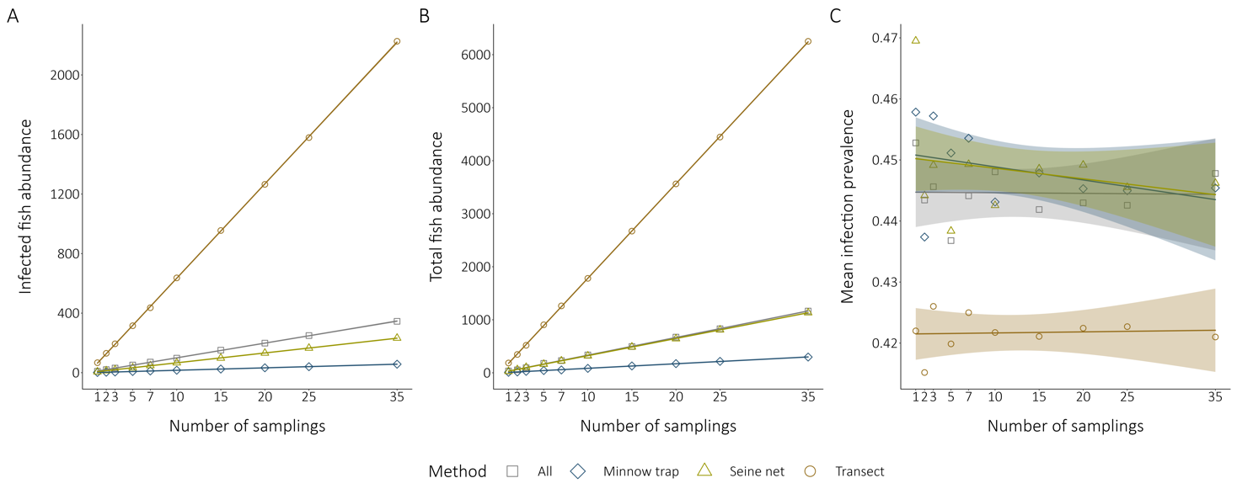

**FIGURE 3**

Accumulation curves of regional-scale sampling through an increasing sampling intensity. The different sampling methods are compared for all three simulations. The data points indicate the mean prevalence for a given sampling intensity. The pool data for all methods, minnow traps, seine nets and transects respectively contained 339, 225, 75 and 39 samplings. **A.** The accumulation of the infected fish abundance. **B.** The accumulation of the total fish abundance. **C.** The accumulation of the regional mean community prevalence.

***3.2. Local scale***

We compared the frequency distribution of the local lake’s prevalence of all sampling methods to see how the regional prevalence is distributed at a local scale (Figure 4).

**FIGURE 4**

Comparison of the frequency distribution of the local community prevalence depending on the sampling method. All the frequency distributions considered 14 lakes, except for the transect method that survey 11 lakes. **A.** The local prevalence estimation considers that data from all the sampling methods. The regional community prevalence is 29.55% **B.** The local prevalence estimation considers that data from the transect method. The regional community prevalence is 35.55%. **C.** The local prevalence estimation considers that data from the seine nets. The regional community prevalence is 20.43%. **D.** The local prevalence estimation considers that data from the minnow traps. The regional community prevalence is 19.20%.

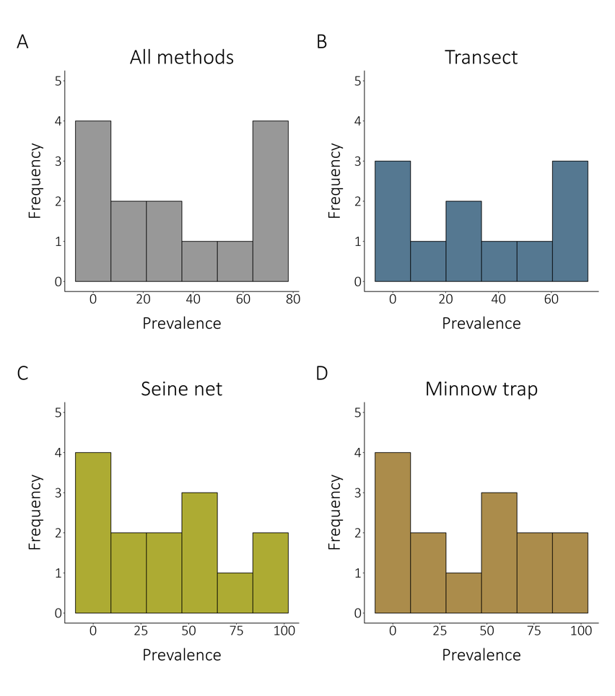

The local community prevalence estimations are not constant across the regional scale. The local prevalence frequency distributions for the combined methods (A) and for the transect method seem to show a bimodal distribution, displaying more low-prevalence and high-prevalence lakes than mid-prevalence lakes. The distribution patterns are more unclear for both the fishing methods (seine nets and minnow traps), although they seem left-hand displaying more low-prevalence lakes (C and D). Heavily infected lakes and lightly infected lakes do not appear to be clustered in space at the regional scale (Figure 2). Moreover, close and connected lakes appear to follow a gradient of infection.

***3.2. Fine scale***

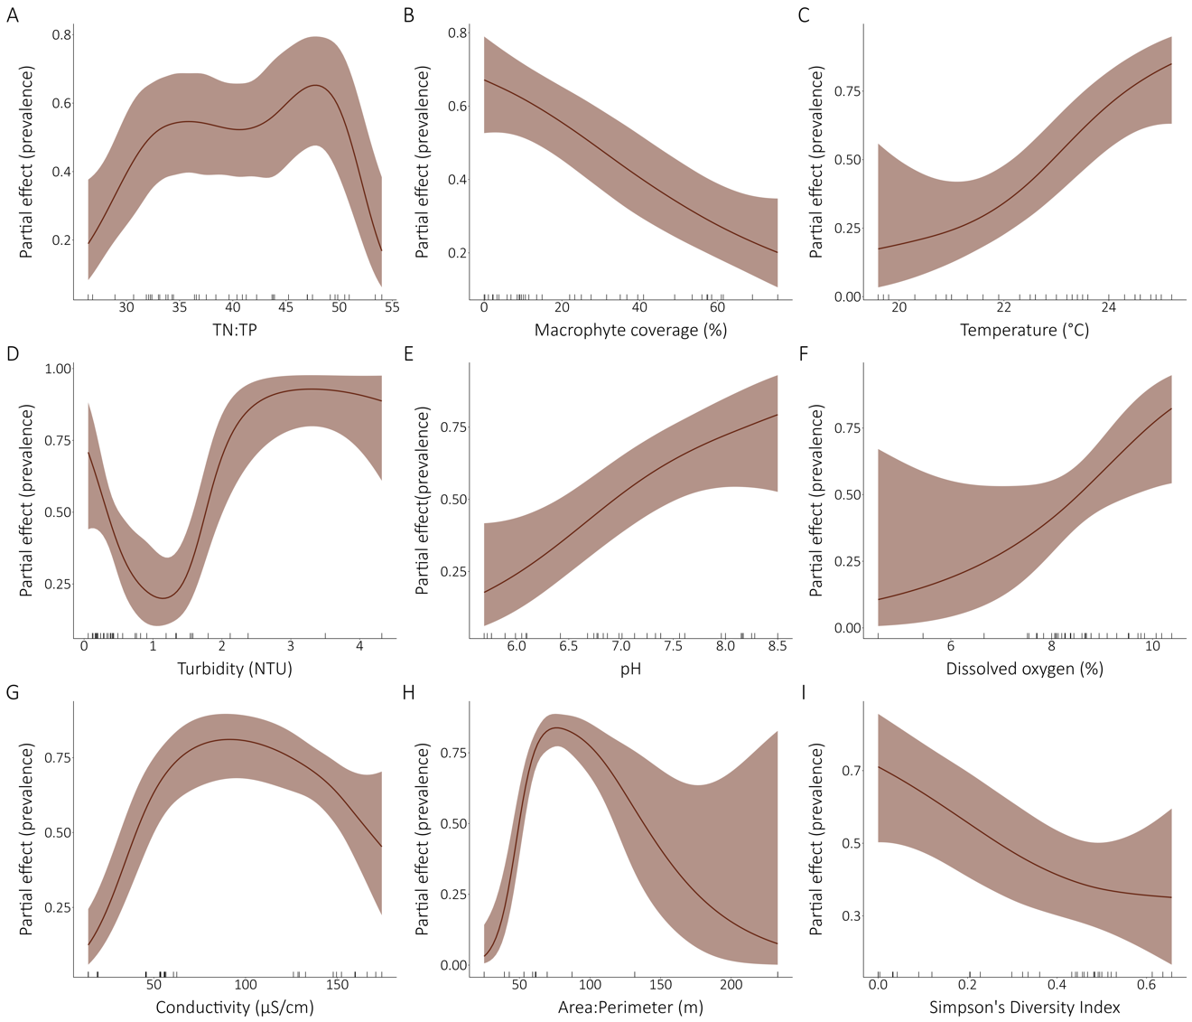

**FIGURE 5**

Relations between the fine-scale community infection prevalence and selected environmental drivers. All the models presented are univariate binomial generalized additive mixed models with the lake as a random effect on the intercept. The significative partial effects of the environmental variables on the prevalence are presented. The ticks on the x-axes indicate a data point. TN:TP ratio, macrophyte coverage, temperature, turbidity, pH, dissolved oxygen, conductivity and Simpson’s Diversity Index are fine-scale measurements while area:perimeter ratio is a local attribute. The perimeter model is not presented because it was highly unlinear and not interpretable although significative.

Relation between potential predictors and fine-scale prevalence (transect prevalence) were assessed with generalized additive mixed models (GAMMs). Partial effects of prevalence modelling are shown for all significant variables in Figure X. Models for TN, TP, TOC, lake area, maximum depth, mean depth, water residency time, drainage area, elevation, distance to nearest lake, centrarchid abundance and species richness were not significant.

1. Probably unimodal relation
2. Inversely proportional relation
3. Increasingly proportional relation
4. Unlinear relation. Few sites with high turbidity (NTU > 2).
5. Increasingly proportional relation
6. Increasingly proportional relation. Few values below 7% showed by high variaiton
7. Parabolic relation. No values around 100.
8. Parabolic relation. Only 2 lakes above 100 m leading to high variation
9. Highly unlinear relation. Only two lakes above 10 000 m. Below 7000, unimodal relation
10. Inverse relation.

Summary table All models. Significant in bold.

*** Vérifier que biotic data used is at transect-scale. Which data?